**A.Y 2023-24**

**Industry Practice**

**Project Report On**

***Random Number Guess using JavaScript with responsive UI***

**Submitted by:**

**Aryan Raina-37**

**Akshay Rao-38**

**Disha Rathod-39**

**Lokesh Rathod-40**

**Under the guidance of: Prof. Anand Maha**

**Department of**

**Artificial Intelligence and Machine Learning**

**Project Overview:**

The Front-End Development Project aimed to create a user-friendly and visually appealing E-Commerce website for [Company Name]. The project's scope encompassed the design and implementation of the website's user interface, navigation, product presentation, and user experience.

**Project Objectives:**

* Design an intuitive and responsive user interface that caters to various device sizes and screen resolutions.
* Develop a seamless navigation system to enhance user journey and engagement.
* Implement effective product showcasing, enabling easy browsing and selection.
* Ensure optimal performance, fast loading times, and smooth interactions.
* Maintain consistent branding and visual aesthetics throughout the website.
* Incorporate user feedback to refine and enhance the user experience.

**Project Deliverables:**

* **Wireframes and Mock-ups:** Detailed wireframes and mock-ups were created to visualize the layout, structure, and visual elements of the website.
* **HTML/CSS/JavaScript:** The front-end codebase was developed using modern web technologies to translate the design into a functional and interactive website.
* **Responsive Design:** The website was optimized for various devices, including desktops, tablets, and smartphones, to ensure consistent user experience across platforms.
* **Navigation System:** A user-friendly navigation system was implemented, including menus, categories, and filters for easy product discovery.
* **Product Presentation:** Product pages were designed to showcase products attractively, including high-quality images, detailed descriptions, and user reviews.
* **User Experience:** User interactions, such as adding to cart, Wishlist management, and checkout process, were designed to be intuitive and efficient.
* **Performance Optimization:** Techniques like image compression, minification of code, and caching were employed to achieve fast loading times and smooth interactions.

**Challenges and Solutions:**

* Cross-Browser Compatibility: Ensured consistent appearance and functionality across various web browsers by testing and applying browser-specific CSS adjustments.
* Responsive Design: Addressed responsiveness challenges through media queries and flexible layout design, accommodating different screen sizes and orientations.
* Performance: Optimized images, utilized lazy loading, and minimized HTTP requests to enhance website loading speed and overall performance.
* Accessibility: Ensured compliance with accessibility standards, including proper use of semantic HTML, contrast ratios, and ARIA roles for screen readers.
* Feedback Incorporation: Regularly gathered user feedback and iterated on the design and functionality to enhance user satisfaction.

**Achievements:**

* Successfully delivered an E-Commerce website with an engaging user interface, resulting in increased user engagement and longer session durations.
* Achieved an average page load time of under 2 seconds, contributing to improved user retention and conversion rates.
* Received positive feedback from users regarding the intuitive navigation, product presentation, and overall shopping experience.
* Implemented responsive design principles, resulting in seamless usability across a wide range of devices.

**Result and Discussion:**

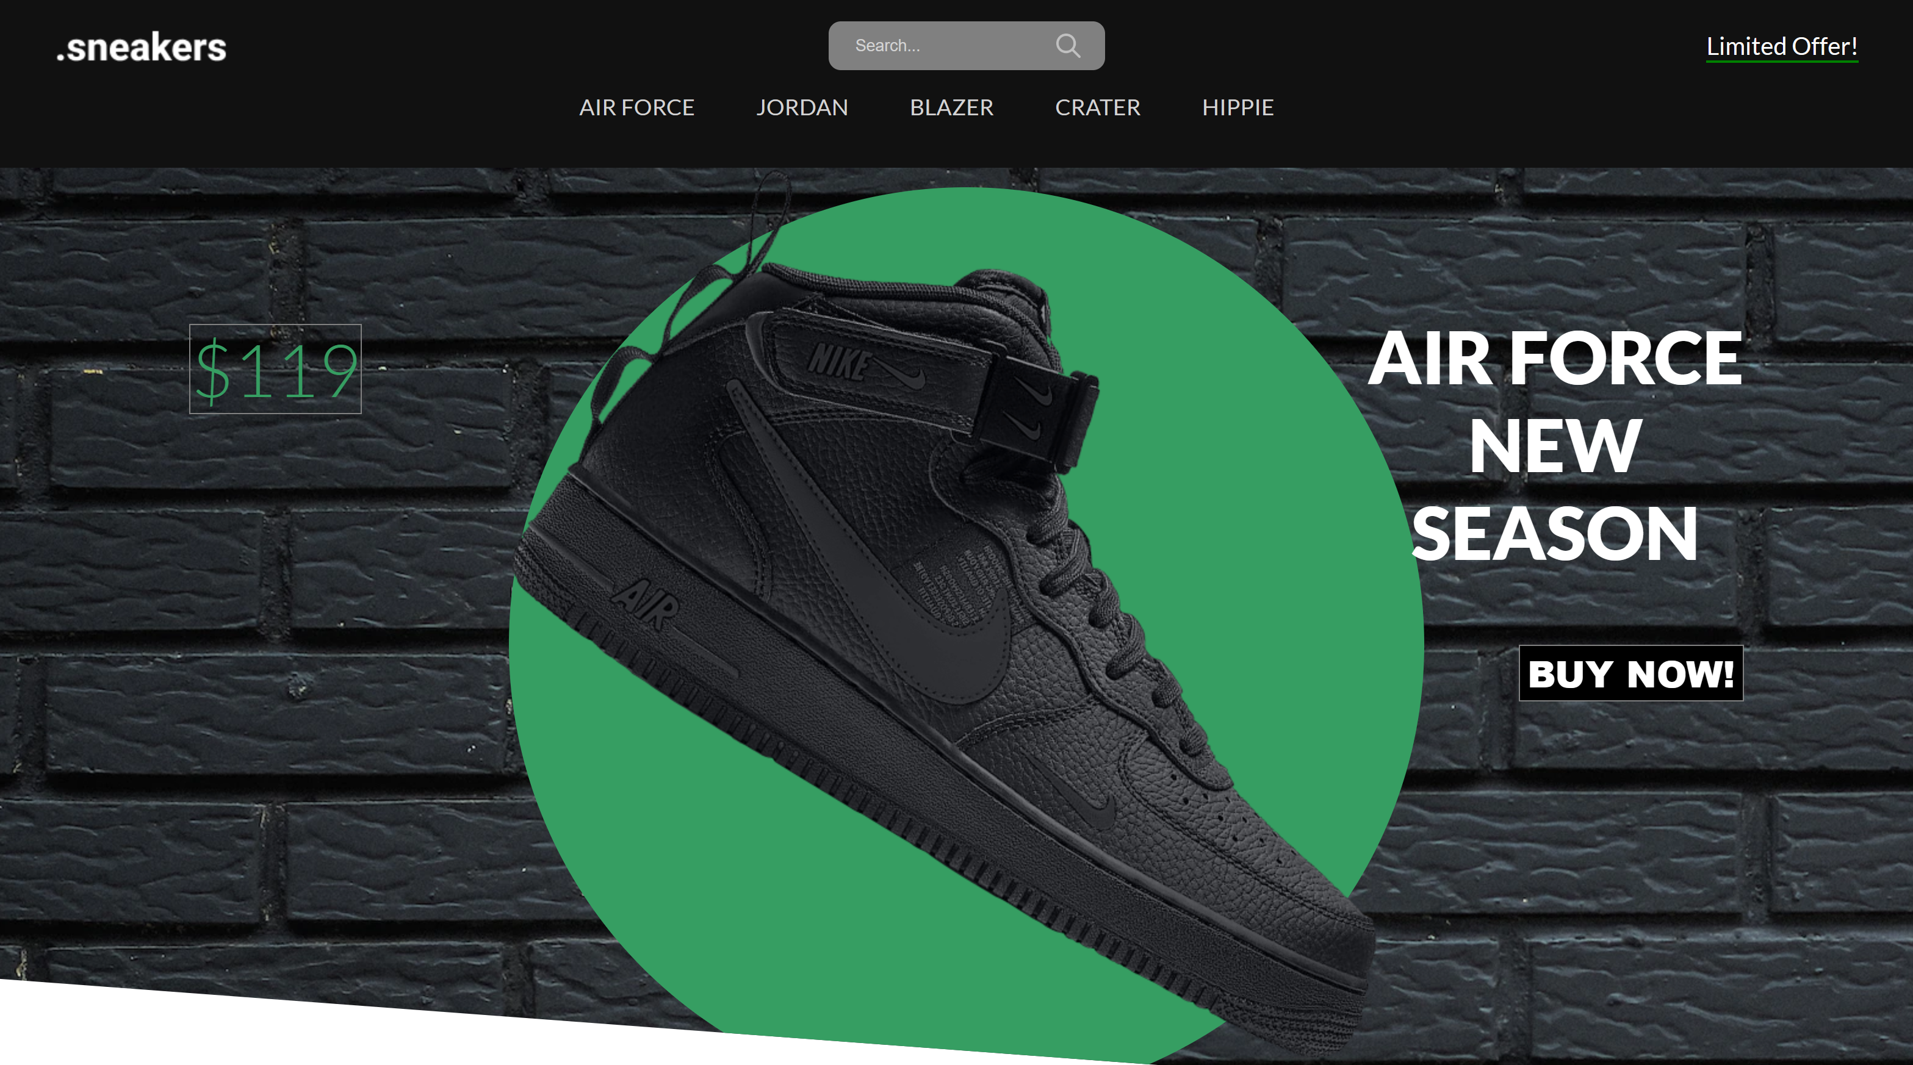

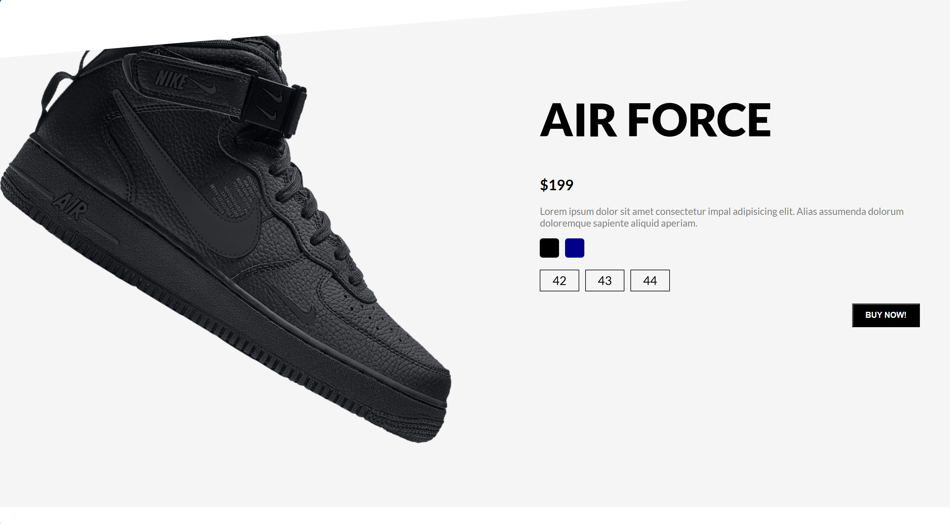

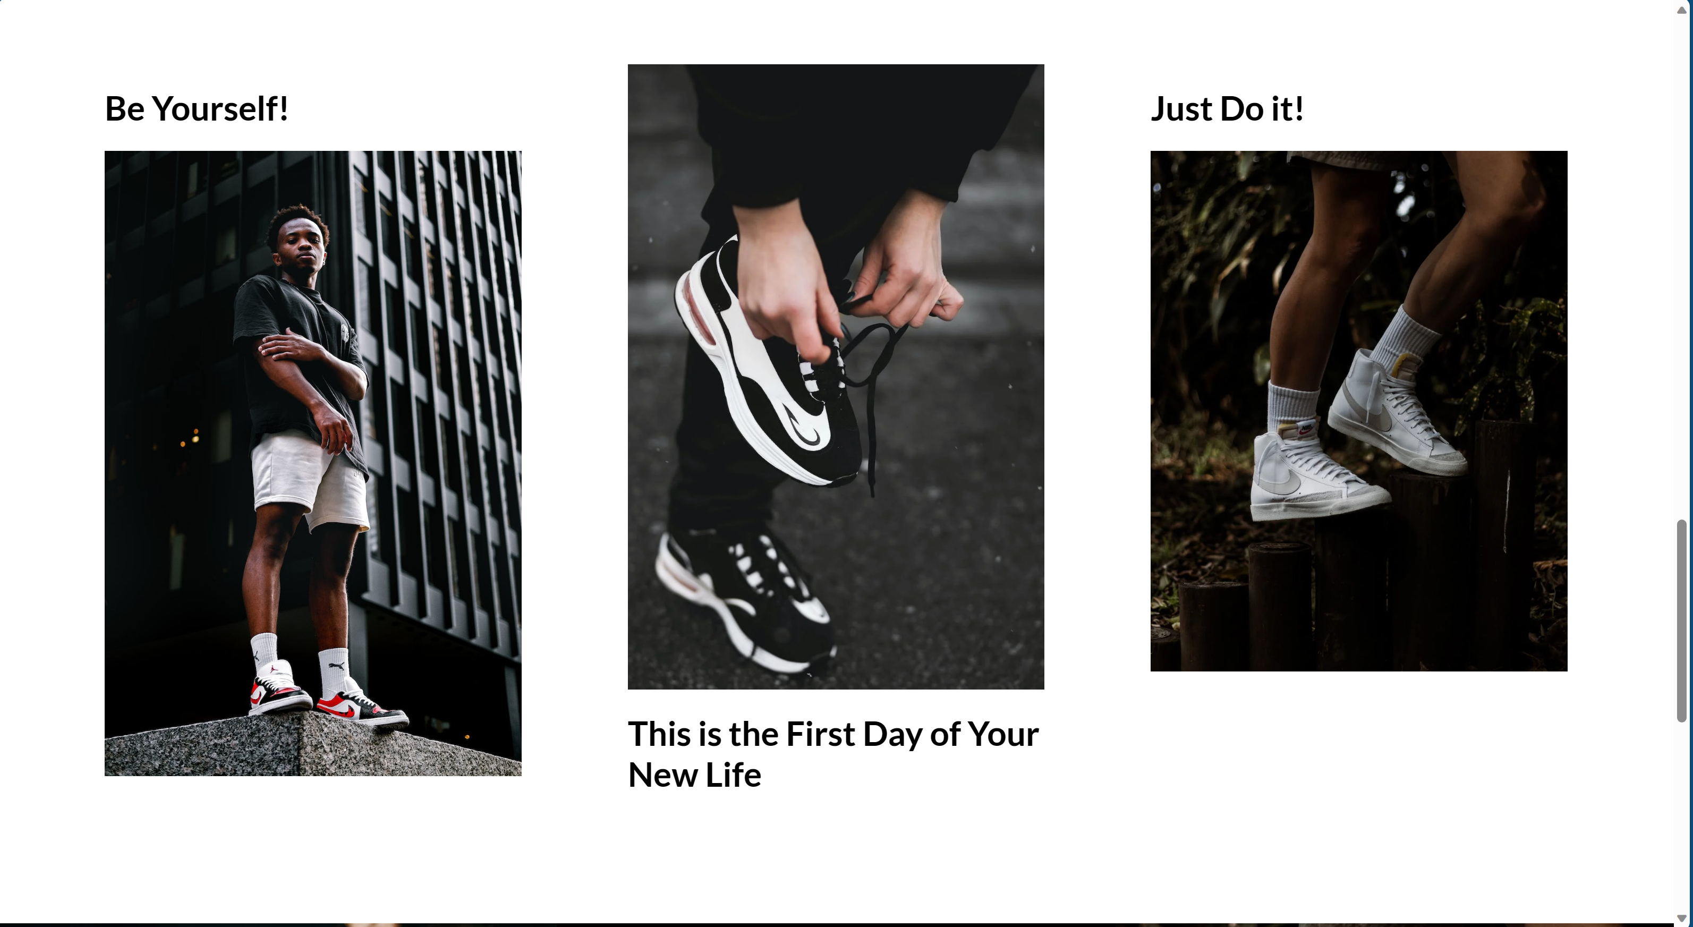

**Annexture:**

**HTML File:**

<html lang="en">

<head>

    <meta charset="UTF-8">

    <meta http-equiv="X-UA-Compatible" content="IE=edge">

    <meta name="viewport" content="width=device-width, initial-scale=1.0">

    <link

        href="https://fonts.googleapis.com/css2?family=Lato:ital,wght@0,100;0,300;0,400;0,700;0,900;1,100;1,300;1,400;1,700;1,900&display=swap"

        rel="stylesheet">

    <link rel="stylesheet" href="style.css">

    <title>Nike Store</title>

</head>

<body>

    <nav id="nav">

        <!-- Here we have created a nav bar -->

        <div class="navTop">

            <div class="navItem">

                <!-- Here we have added the logo of i=our website -->

                <img src="./img/sneakers.png" alt="">

            </div>

            <!-- We have created a search bar  -->

            <div class="navItem">

                <div class="search">

                    <input type="text" placeholder="Search..." class="searchInput">

                    <!-- We have added the serach icon -->

                    <img src="./img/search.png" width="20" height="20" alt="" class="searchIcon">

                </div>

            </div>

            <div class="navItem">

                <span class="limitedOffer">Limited Offer!</span>

            </div>

        </div>

        <!-- We have just added the differnt styles into the navbar -->

        <div class="navBottom">

            <h3 class="menuItem">AIR FORCE</h3>

            <h3 class="menuItem">JORDAN</h3>

            <h3 class="menuItem">BLAZER</h3>

            <h3 class="menuItem">CRATER</h3>

            <h3 class="menuItem">HIPPIE</h3>

        </div>

    </nav>

    <!-- We are creating a slider for each style of shoe mentioned above -->

    <div class="slider">

        <div class="sliderWrapper">

            <div class="sliderItem">

                <img src="./img/air.png" alt="" class="sliderImg">

                <div class="sliderBg"></div>

                <h1 class="sliderTitle">AIR FORCE</br> NEW</br> SEASON</h1>

                <h2 class="sliderPrice">$119</h2>

                <a href="#product">

                    <button class="buyButton">BUY NOW!</button>

                </a>

            </div>

            <div class="sliderItem">

                <img src="./img/jordan.png" alt="" class="sliderImg">

                <div class="sliderBg"></div>

                <h1 class="sliderTitle">AIR JORDAN</br> NEW</br> SEASON</h1>

                <h2 class="sliderPrice">$149</h2>

                <a href="#product">

                    <button class="buyButton">BUY NOW!</button>

                </a>

            </div>

            <div class="sliderItem">

                <img src="./img/blazer.png" alt="" class="sliderImg">

                <div class="sliderBg"></div>

                <h1 class="sliderTitle">BLAZER</br> NEW</br> SEASON</h1>

                <h2 class="sliderPrice">$109</h2>

                <a href="#product">

                    <button class="buyButton">BUY NOW!</button>

                </a>

            </div>

            <div class="sliderItem">

                <img src="./img/crater.png" alt="" class="sliderImg">

                <div class="sliderBg"></div>

                <h1 class="sliderTitle">CRATER</br> NEW</br> SEASON</h1>

                <h2 class="sliderPrice">$129</h2>

                <a href="#product">

                    <button class="buyButton">BUY NOW!</button>

                </a>

            </div>

            <div class="sliderItem">

                <img src="./img/hippie.png" alt="" class="sliderImg">

                <div class="sliderBg"></div>

                <h1 class="sliderTitle">HIPPIE</br> NEW</br> SEASON</h1>

                <h2 class="sliderPrice">$99</h2>

                <a href="#product">

                    <button class="buyButton">BUY NOW!</button>

                </a>

            </div>

        </div>

    </div>

    <div class="features">

        <div class="feature">

            <img src="./img/shipping.png" alt="" class="featureIcon">

            <span class="featureTitle">FREE SHIPPING</span>

            <span class="featureDesc">Free worldwide shipping on all orders.</span>

        </div>

        <div class="feature">

            <img class="featureIcon" src="./img/return.png" alt="">

            <span class="featureTitle">30 DAYS RETURN</span>

            <span class="featureDesc">No question return and easy refund in 14 days.</span>

        </div>

        <div class="feature">

            <img class="featureIcon" src="./img/gift.png" alt="">

            <span class="featureTitle">GIFT CARDS</span>

            <span class="featureDesc">Buy gift cards and use coupon codes easily.</span>

        </div>

        <div class="feature">

            <img class="featureIcon" src="./img/contact.png" alt="">

            <span class="featureTitle">CONTACT US!</span>

            <span class="featureDesc">Keep in touch via email and support system.</span>

        </div>

    </div>

    <div class="product" id="product">

        <img src="./img/air.png" alt="" class="productImg">

        <div class="productDetails">

            <h1 class="productTitle">AIR FORCE</h1>

            <h2 class="productPrice">$199</h2>

            <p class="productDesc">Lorem ipsum dolor sit amet consectetur impal adipisicing elit. Alias assumenda

                dolorum

                doloremque sapiente aliquid aperiam.</p>

            <div class="colors">

                <div class="color"></div>

                <div class="color"></div>

            </div>

            <div class="sizes">

                <div class="size">42</div>

                <div class="size">43</div>

                <div class="size">44</div>

            </div>

            <button class="productButton">BUY NOW!</button>

        </div>

        <div class="payment">

            <h1 class="payTitle">Personal Information</h1>

            <label>Name and Surname</label>

            <input type="text" placeholder="John Doe" class="payInput">

            <label>Phone Number</label>

            <input type="text" placeholder="+1 234 5678" class="payInput">

            <label>Address</label>

            <input type="text" placeholder="Elton St 21 22-145" class="payInput">

            <h1 class="payTitle">Card Information</h1>

            <div class="cardIcons">

                <img src="./img/visa.png" width="40" alt="" class="cardIcon">

                <img src="./img/master.png" alt="" width="40" class="cardIcon">

            </div>

            <input type="password" class="payInput" placeholder="Card Number">

            <div class="cardInfo">

                <input type="text" placeholder="mm" class="payInput sm">

                <input type="text" placeholder="yyyy" class="payInput sm">

                <input type="text" placeholder="cvv" class="payInput sm">

            </div>

            <button class="payButton">Checkout!</button>

            <span class="close">X</span>

        </div>

    </div>

    <div class="gallery">

        <div class="galleryItem">

            <h1 class="galleryTitle">Be Yourself!</h1>

            <img src="https://images.pexels.com/photos/9295809/pexels-photo-9295809.jpeg?auto=compress&cs=tinysrgb&dpr=2&w=500"

                alt="" class="galleryImg">

        </div>

        <div class="galleryItem">

            <img src="https://images.pexels.com/photos/1040427/pexels-photo-1040427.jpeg?auto=compress&cs=tinysrgb&dpr=2&w=500"

                alt="" class="galleryImg">

            <h1 class="galleryTitle">This is the First Day of Your New Life</h1>

        </div>

        <div class="galleryItem">

            <h1 class="galleryTitle">Just Do it!</h1>

            <img src="https://images.pexels.com/photos/7856965/pexels-photo-7856965.jpeg?auto=compress&cs=tinysrgb&dpr=2&w=500"

                alt="" class="galleryImg">

        </div>

    </div>

    <div class="newSeason">

        <div class="nsItem">

            <img src="https://images.pexels.com/photos/4753986/pexels-photo-4753986.jpeg?auto=compress&cs=tinysrgb&dpr=2&w=500"

                alt="" class="nsImg">

        </div>

        <div class="nsItem">

            <h3 class="nsTitleSm">WINTER NEW ARRIVALS</h3>

            <h1 class="nsTitle">New Season</h1>

            <h1 class="nsTitle">New Collection</h1>

            <a href="#nav">

                <button class="nsButton">CHOOSE YOUR STYLE</button>

            </a>

        </div>

        <div class="nsItem">

            <img src="https://images.pexels.com/photos/7856965/pexels-photo-7856965.jpeg?auto=compress&cs=tinysrgb&dpr=2&w=500"

                alt="" class="nsImg">

        </div>

    </div>

    <footer>

        <div class="footerLeft">

            <div class="footerMenu">

                <h1 class="fMenuTitle">About Us</h1>

                <ul class="fList">

                    <li class="fListItem">Company</li>

                    <li class="fListItem">Contact</li>

                    <li class="fListItem">Careers</li>

                    <li class="fListItem">Affiliates</li>

                    <li class="fListItem">Stores</li>

                </ul>

            </div>

            <div class="footerMenu">

                <h1 class="fMenuTitle">Useful Links</h1>

                <ul class="fList">

                    <li class="fListItem">Support</li>

                    <li class="fListItem">Refund</li>

                    <li class="fListItem">FAQ</li>

                    <li class="fListItem">Feedback</li>

                    <li class="fListItem">Stories</li>

                </ul>

            </div>

            <div class="footerMenu">

                <h1 class="fMenuTitle">Products</h1>

                <ul class="fList">

                    <li class="fListItem">Air Force</li>

                    <li class="fListItem">Air Jordan</li>

                    <li class="fListItem">Blazer</li>

                    <li class="fListItem">Crater</li>

                    <li class="fListItem">Hippie</li>

                </ul>

            </div>

        </div>

        <div class="footerRight">

            <div class="footerRightMenu">

                <h1 class="fMenuTitle">Subscribe to our newsletter</h1>

                <div class="fMail">

                    <input type="text" placeholder="your@email.com" class="fInput">

                    <button class="fButton">Join!</button>

                </div>

            </div>

            <div class="footerRightMenu">

                <h1 class="fMenuTitle">Follow Us</h1>

                <div class="fIcons">

                    <img src="./img/facebook.png" alt="" class="fIcon">

                    <img src="./img/twitter.png" alt="" class="fIcon">

                    <img src="./img/instagram.png" alt="" class="fIcon">

                    <img src="./img/whatsapp.png" alt="" class="fIcon">

                </div>

            </div>

            <div class="footerRightMenu">

                <span class="copyright">All rights reserved. 2022.</span>

            </div>

        </div>

    </footer>

    <script src="./app.js"></script>

</body>

</html>

# CSS File:

html {

    scroll-behavior: smooth;

  }

  body {

    font-family: "Lato", sans-serif;

    padding: 0;

    margin: 0;

  }

  /* We have added some colours for the nav bar */

  nav {

    background-color: #111;

    color: white;

    padding: 20px 50px;

  }

  /* To allign all the elements in the navbar */

  .navTop {

    display: flex;

    align-items: center;

    justify-content: space-between;

  }

  /* We have added some colours for the search bar */

  .search {

    display: flex;

    align-items: center;

    background-color: gray;

    padding: 10px 20px;

    border-radius: 10px;

  }

  .searchInput {

    border: none;

    background-color: transparent;

  }

  /* To able to see the wordings on the search bar */

  .searchInput::placeholder {

    color: lightgray;

  }

  /* For limited offer logo */

  .limitedOffer {

    font-size: 20px;

    border-bottom: 2px solid green;

    cursor: pointer;

  }

  /* It is for the shoe styles */

  .navBottom {

    display: flex;

    align-items: center;

    justify-content: center;

  }

  /* For each item and to add space between */

  .menuItem {

    margin-right: 50px;

    cursor: pointer;

    color: lightgray;

    font-weight: 400;

  }

  /* We have added a background image  */

  .slider {

    background: url("https://images.unsplash.com/photo-1604147495798-57beb5d6af73?ixlib=rb-1.2.1&ixid=MnwxMjA3fDB8MHxwaG90by1wYWdlfHx8fGVufDB8fHx8&auto=format&fit=crop&w=2370&q=80");

    clip-path: polygon(0 0, 100% 0, 100% 100%, 0 85%);

    overflow: hidden;

  }

  .sliderWrapper {

    display: flex;

    width: 500vw;

    transition: all 1.5s ease-in-out;

  }

  .sliderItem {

    width: 100vw;

    display: flex;

    align-items: center;

    justify-content: center;

    position: relative;

  }

  .sliderBg {

    width: 750px;

    height: 750px;

    border-radius: 50%;

    position: absolute;

  }

  .sliderImg {

    z-index: 1;

  }

  /* For the text of each slider element or shoe */

  .sliderTitle {

    position: absolute;

    top: 10%;

    right: 10%;

    font-size: 60px;

    font-weight: 900;

    text-align: center;

    color: white;

    z-index: 1;

  }

  /* For the text of each slider element price or shoe price */

  .sliderPrice {

    position: absolute;

    top: 10%;

    left: 10%;

    font-size: 60px;

    font-weight: 300;

    text-align: center;

    color: white;

    border: 1px solid gray;

    z-index: 1;

  }

  .buyButton {

    position: absolute;

    top: 50%;

    right: 10%;

    font-size: 30px;

    font-weight: 900;

    color: white;

    border: 1px solid gray;

    background-color: black;

    z-index: 1;

    cursor: pointer;

  }

  .buyButton:hover {

    background-color: white;

    color: black;

  }

  .sliderItem:nth-child(1) .sliderBg {

    background-color: #369e62;

  }

  .sliderItem:nth-child(2) .sliderBg {

    background-color: rebeccapurple;

  }

  .sliderItem:nth-child(3) .sliderBg {

    background-color: teal;

  }

  .sliderItem:nth-child(4) .sliderBg {

    background-color: cornflowerblue;

  }

  .sliderItem:nth-child(5) .sliderBg {

    background-color: rgb(124, 115, 80);

  }

  .sliderItem:nth-child(1) .sliderPrice {

    color: #369e62;

  }

  .sliderItem:nth-child(2) .sliderPrice {

    color: white;

  }

  .sliderItem:nth-child(3) .sliderPrice {

    color: teal;

  }

  .sliderItem:nth-child(4) .sliderPrice {

    color: cornflowerblue;

  }

  .sliderItem:nth-child(5) .sliderPrice {

    color: cornsilk;

  }

  .features {

    display: flex;

    align-items: center;

    justify-content: space-between;

    padding: 50px;

  }

  .feature {

    display: flex;

    flex-direction: column;

    align-items: center;

    text-align: center;

  }

  .featureIcon {

    width: 50px;

    height: 50px;

  }

  .featureTitle {

    font-size: 20px;

    font-weight: 600;

    margin: 20px;

  }

  .featureDesc {

    color: gray;

    width: 50%;

    height: 100px;

  }

  .product {

    height: 100vh;

    background-color: whitesmoke;

    position: relative;

    clip-path: polygon(0 15%, 100% 0, 100% 100%, 0% 100%);

  }

  .payment {

    width: 500px;

    height: 500px;

    background-color: white;

    position: absolute;

    top: 0;

    bottom: 0;

    left: 0;

    right: 0;

    margin: auto;

    padding: 10px 50px;

    display: none;

    flex-direction: column;

    -webkit-box-shadow: 0px 0px 13px 2px rgba(0, 0, 0, 0.3);

    box-shadow: 0px 0px 13px 2px rgba(0, 0, 0, 0.3);

  }

  .payTitle {

    font-size: 20px;

    color: lightgray;

  }

  label {

    font-size: 14px;

    font-weight: 300;

  }

  .payInput {

    padding: 10px;

    margin: 10px 0px;

    border: none;

    border-bottom: 1px solid gray;

  }

  .payInput::placeholder {

    color: rgb(163, 163, 163);

  }

  .cardIcons {

    display: flex;

  }

  .cardIcon {

    margin-right: 10px;

  }

  .cardInfo {

    display: flex;

    justify-content: space-between;

  }

  .sm {

    width: 30%;

  }

  .payButton {

    position: absolute;

    height: 40px;

    bottom: -40;

    width: 100%;

    left: 0;

    -webkit-box-shadow: 0px 0px 13px 2px rgba(0, 0, 0, 0.3);

    box-shadow: 0px 0px 13px 2px rgba(0, 0, 0, 0.3);

    background-color: #369e62;

    color: white;

    border: none;

    cursor: pointer;

  }

  .close {

    width: 20px;

    height: 20px;

    position: absolute;

    background-color: gray;

    color: white;

    top: 10px;

    right: 10px;

    display: flex;

    align-items: center;

    justify-content: center;

    cursor: pointer;

    padding: 2px;

  }

  .productImg {

    width: 50%;

  }

  .productDetails {

    position: absolute;

    top: 10%;

    right: 0;

    width: 40%;

    padding: 50px;

  }

  .productTitle {

    font-size: 75px;

    font-weight: 900;

  }

  .productDesc {

    font-style: 24px;

    color: gray;

  }

  .colors,

  .sizes {

    display: flex;

    margin-bottom: 20px;

  }

  .color {

    width: 32px;

    height: 32px;

    border-radius: 5px;

    background-color: black;

    margin-right: 10px;

    cursor: pointer;

  }

  .color:last-child {

    background-color: darkblue;

  }

  .size {

    padding: 5px 20px;

    border: 1px solid black;

    margin-right: 10px;

    cursor: pointer;

    font-size: 20px;

  }

  .productButton {

    float: right;

    padding: 10px 20px;

    background-color: black;

    color: white;

    font-weight: 600;

    cursor: pointer;

  }

  .productButton:hover {

    background-color: white;

    color: black;

  }

  .gallery {

    padding: 50px;

    display: flex;

  }

  .galleryItem {

    flex: 1;

    padding: 50px;

  }

  .galleryImg {

    width: 100%;

  }

  .newSeason {

    display: flex;

  }

  .nsItem {

    flex: 1;

    background-color: black;

    color: white;

    display: flex;

    flex-direction: column;

    align-items: center;

    justify-content: center;

    text-align: center;

  }

  .nsImg {

    width: 100%;

    height: 500px;

  }

  .nsTitle {

    font-size: 40px;

  }

  .nsButton {

    padding: 15px;

    font-weight: 600;

    cursor: pointer;

  }

  footer {

    display: flex;

  }

  .footerLeft {

    flex: 2;

    display: flex;

    justify-content: space-between;

    padding: 50px;

  }

  .fMenuTitle {

    font-size: 16px;

  }

  .fList {

    padding: 0;

    list-style: none;

  }

  .fListItem {

    margin-bottom: 10px;

    color: gray;

    cursor: pointer;

  }

  .footerRight {

    flex: 1;

    padding: 50px;

    display: flex;

    flex-direction: column;

    justify-content: space-between;

  }

  .fInput {

    padding: 5px;

  }

  .fButton {

    padding: 5px;

    background-color: black;

    color: white;

  }

  .fIcons{

    display: flex;

  }

  .fIcon{

    width: 20px;

    height: 20px;

    margin-right: 10px;

  }

  .copyright{

    font-weight: 300;

    font-size: 14px;

  }

  @media screen and (max-width:480px) {

    nav{

      padding: 20px;

    }

    .search{

      display: none;

    }

    .navBottom{

      flex-wrap: wrap;

    }

    .menuItem{

      margin: 20px;

      font-weight: 700;

      font-size: 20px;

    }

    .slider{

      clip-path: none;

    }

    .sliderImg{

      width: 90%;

    }

    .sliderBg{

      width: 100%;

      height: 100%;

    }

    .sliderTitle{

      display: none;

    }

    .sliderPrice{

      top: unset;

      bottom: -50;

      left: 0;

      background-color: lightgrey;

    }

    .buyButton{

      right: 0;

      top: 0;

    }

    .features{

      flex-direction: column;

    }

    .product{

      clip-path: none ;

      display: flex;

      flex-direction: column;

      align-items: center;

    }

    .productImg{

      width: 80%;

    }

    .productDetails{

      width: 100%;

      padding: 0;

      display: flex;

      flex-direction: column;

      align-items: center;

      text-align: center;

      position: relative;

      top: 0;

    }

    .productTitle{

      font-size: 50px;

      margin: 0;

    }

    .gallery{

      display: none;

    }

    .newSeason{

      flex-direction: column;

    }

    .nsItem:nth-child(2){

      padding: 50px;

    }

    footer{

      flex-direction: column;

      align-items: center;

    }

    .footerLeft{

      padding: 20px;

      width: 90%;

    }

    .footerRight{

      padding: 20px;

      width: 90%;

      align-items: center;

      background-color: whitesmoke;

    }

    .payment{

      width: 90%;

      padding: 20px;

    }

  }

# Java Script File:

const wrapper = document.querySelector(".sliderWrapper");

const menuItems = document.querySelectorAll(".menuItem");

const products = [

  {

    id: 1,

    title: "Air Force",

    price: 119,

    colors: [

      {

        code: "black",

        img: "./img/air.png",

      },

      {

        code: "darkblue",

        img: "./img/air2.png",

      },

    ],

  },

  {

    id: 2,

    title: "Air Jordan",

    price: 149,

    colors: [

      {

        code: "lightgray",

        img: "./img/jordan.png",

      },

      {

        code: "green",

        img: "./img/jordan2.png",

      },

    ],

  },

  {

    id: 3,

    title: "Blazer",

    price: 109,

    colors: [

      {

        code: "lightgray",

        img: "./img/blazer.png",

      },

      {

        code: "green",

        img: "./img/blazer2.png",

      },

    ],

  },

  {

    id: 4,

    title: "Crater",

    price: 129,

    colors: [

      {

        code: "black",

        img: "./img/crater.png",

      },

      {

        code: "lightgray",

        img: "./img/crater2.png",

      },

    ],

  },

  {

    id: 5,

    title: "Hippie",

    price: 99,

    colors: [

      {

        code: "gray",

        img: "./img/hippie.png",

      },

      {

        code: "black",

        img: "./img/hippie2.png",

      },

    ],

  },

];

let choosenProduct = products[0];

const currentProductImg = document.querySelector(".productImg");

const currentProductTitle = document.querySelector(".productTitle");

const currentProductPrice = document.querySelector(".productPrice");

const currentProductColors = document.querySelectorAll(".color");

const currentProductSizes = document.querySelectorAll(".size");

menuItems.forEach((item, index) => {

  item.addEventListener("click", () => {

    //change the current slide

    wrapper.style.transform = `translateX(${-100 * index}vw)`;

    //change the choosen product

    choosenProduct = products[index];

    //change texts of currentProduct

    currentProductTitle.textContent = choosenProduct.title;

    currentProductPrice.textContent = "$" + choosenProduct.price;

    currentProductImg.src = choosenProduct.colors[0].img;

    //assing new colors

    currentProductColors.forEach((color, index) => {

      color.style.backgroundColor = choosenProduct.colors[index].code;

    });

  });

});

currentProductColors.forEach((color, index) => {

  color.addEventListener("click", () => {

    currentProductImg.src = choosenProduct.colors[index].img;

  });

});

currentProductSizes.forEach((size, index) => {

  size.addEventListener("click", () => {

    currentProductSizes.forEach((size) => {

      size.style.backgroundColor = "white";

      size.style.color = "black";

    });

    size.style.backgroundColor = "black";

    size.style.color = "white";

  });

});

const productButton = document.querySelector(".productButton");

const payment = document.querySelector(".payment");

const close = document.querySelector(".close");

productButton.addEventListener("click", () => {

  payment.style.display = "flex";

});

close.addEventListener("click", () => {

  payment.style.display = "none";

});

# 

**Lessons Learned:**

* Regular user testing and feedback collection are crucial for refining the user experience.
* Performance optimization techniques are vital for maintaining user engagement and conversion rates.
* Collaboration between design and development teams is essential to ensure a cohesive and visually appealing end product.

**Conclusion:**

The successful completion of the Front-End Development Project resulted in the creation of a user-centric E-Commerce website that effectively presents products, offers seamless navigation, and enhances the overall shopping experience. The project team's efforts in design, development, and optimization have culminated in a website that aligns with the company's branding and meets user expectations for functionality and aesthetics.

**Declaration**

I declare that this written submission represents my ideas in my own words and where others' ideas or words have been included, I have adequately cited and referenced the original sources. I also declare that I have adhered to all principles of academic honesty and integrity and have not misrepresented or fabricated or falsified any idea/data/fact/source in my submission. I understand that any violation of the above will be cause for disciplinary action by the Institute and can also evoke penal action from the sources which have thus not been properly cited or from whom proper permission has not been taken when needed.

(Signature)

Name of the student-1 (Roll No. )

(Signature)

Name of the student-2 (Roll No. )

(Signature)

Name of the student-3 (Roll No. )

(Signature)

Name of the student-4 (Roll No. )

(Signature)

Name of the student-5 (Roll No. )

Date: